Android setup requirements
- App name
- Package name if you need any specific
- Firebase Account (For Google, Facebook, OTP and Push Notifications)
- Onesignal Account (For Push Notifications)
- Facebook Account (For Facebook login)
- AddMob Account(For Baner ads and Reward Video Ads)
- Square logo(512*512 -1024*1024)
- Baner image (1000*500)
- Earn tab baner : Refer and Earn and Lottery baner -If you need different baner in Earn Tab (1000*500)
- Background image for splashscreen(only for background not included logo)
- Logo for splashscreen- Recommend transparentbackground(If you need different logo in splashscreen)
- Below details for generate app certificate
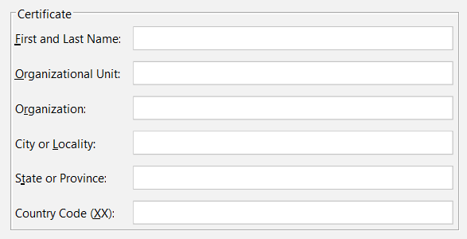

- First and Last Name
- Organizational Unit
- Organization
- City or Locality
- State or Province
- Country Code(XX)

Admin and Website setup requirements

- ftp or cpanel detail
- favicon
- 189x40 logo
- Purchase Code

